**SAS004 Exchange rate**

-Plot Yen/ $ Exchange rate on Year from 1969-1994.

If we define the depreciation (or appreciation of a currency against the US$) as the annual percentage change in the exchange rate

-Then plot the annual appreciation of the Yen against the Dollar between 1969 and 1994.

-Calculate the average appreciation of the Yen/Dollar exchange rate for each of the 3 decades: the 70’s, 80’s and 90’s.

**SAS PROGRAM:**

DATA exchangerate;

INPUT B1-B7;

LABEL b1='year '

b2='Exchange rate (DM/$) '

b3='Exchange rate (Yen/$) '

b4='U.S. Exports '

b5='U.S. Imports '

b6='interest rate (10-year Treasury Bond) '

b7='interest rate (Federal Funds rate) ';

APPRECIATION = (B3 / LAG1(B3) -1)*100;

IF B1 LT 80 AND B1 NE 69 THEN DECADE ='70S';

IF B1 LT 90 AND B1 GE 80 THEN DECADE ='80S';

IF B1 GE 90 THEN DECADE ='90S';

DATALINES;

69 3.9251 358.36 49.3 50.5 6.67 8.2

70 3.6465 358.16 57 55.8 7.35 7.18

71 3.483 347.79 59.3 62.3 6.16 4.66

72 3.1886 303.13 66.2 74.2 6.21 4.43

73 2.6715 271.31 91.8 91.2 6.84 8.73

74 2.5868 291.84 124.3 127.5 7.56 10.5

75 2.4614 296.78 136.3 122.7 7.99 5.82

76 2.5185 296.45 148.9 151.1 7.61 5.04

77 2.3236 268.62 158.8 182.4 7.42 5.54

78 2.0097 210.39 186.1 212.3 8.41 7.93

79 1.8343 219.02 228.9 252.7 9.44 11.19

80 1.8175 226.63 279.2 293.9 11.46 13.36

81 2.2632 220.63 303 317.7 13.91 16.38

82 2.4281 249.06 282.6 303.2 13 12.26

83 2.5539 237.55 276.7 328.1 11.1 9.09

84 2.8455 237.46 302.4 405.1 12.44 10.23

85 2.942 238.47 302.1 417.6 10.62 8.1

86 2.1705 168.35 319.2 451.7 7.68 6.81

87 1.7981 144.6 364 507.1 8.39 6.66

88 1.757 128.17 444.2 552.2 8.85 7.57

89 1.8808 138.07 508 587.7 8.49 9.21

90 1.6166 145 557.1 628.5 8.55 8.1

91 1.661 134.59 601.1 620.9 7.86 5.69

92 1.5618 126.78 638.1 668.4 7.01 3.52

93 1.6545 111.08 659.1 724.3 5.87 3.02

94 1.6216 102.18 716.1 818.2 7.09 4.219

;

PROC SORT; BY DECADE;

SYMBOL I = JOIN;

PROC GPLOT; PLOT B3 * B1;

PLOT APPRECIATION * B1;

PROC MEANS N MEAN; VAR APPRECIATION; BY DECADE; TITLE 'AVERAGE ANNUAL YEN APPRECIATION';

RUN;

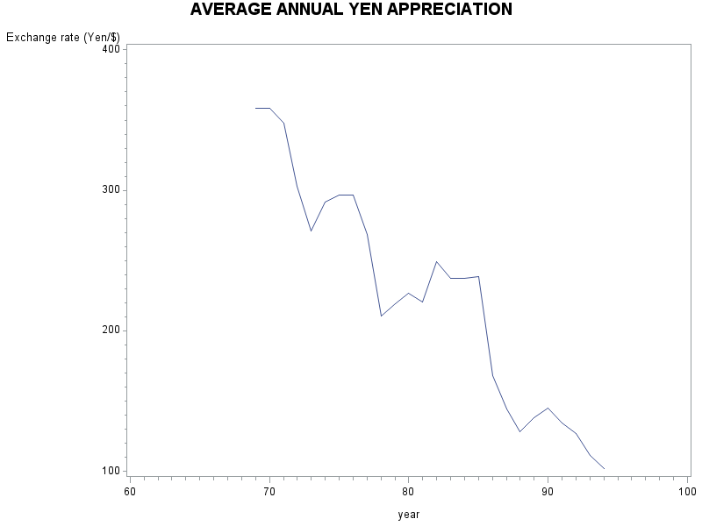

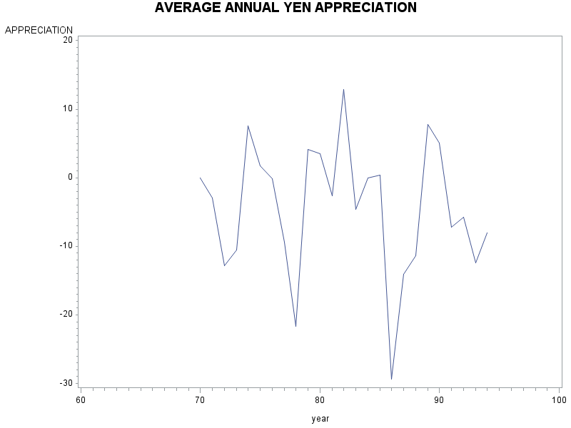

|  |
| --- |
| AVERAGE ANNUAL YEN APPRECIATION |

The MEANS Procedure

DECADE=' '

| **Analysis Variable : APPRECIATION** | |
| --- | --- |
| **N** | **Mean** |
| 0 | . |

DECADE=70S

| **Analysis Variable : APPRECIATION** | |
| --- | --- |
| **N** | **Mean** |
| 10 | -4.4104200 |

DECADE=80S

| **Analysis Variable : APPRECIATION** | |
| --- | --- |
| **N** | **Mean** |
| 10 | -3.7670915 |

DECADE=90S

| **Analysis Variable : APPRECIATION** | |
| --- | --- |
| **N** | **Mean** |
| 5 | -5.6717652 |

**ANSWERS: In the seventies, the Yen appreciated against the Dollar at an average**

**Annual rate of 4.41%.**

**In the eighties, at a rate of 3.77%**

**In the nineties, at a rate of 5.67%**